North Carolina Central University – STEM Program Participant Graduates Early

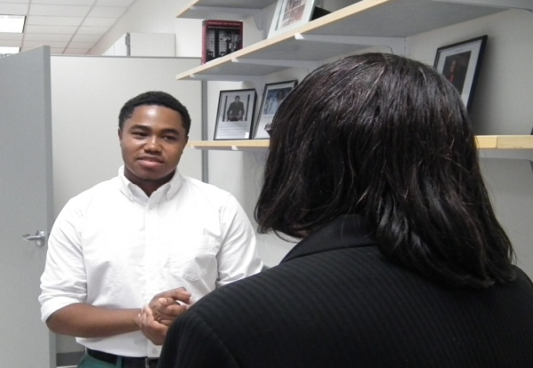
Kendall Kennedy highlights his path to graduating in three years to
Marilyn Foote-Hudson,
Executive Director, North Carolina GlaxoSmithKline Foundation.

(May 11, 2015) Kendall Kennedy, born and raised in Charlottesville, Virginia, grew up in a household where education was a central value. His parents, Brian and Kimberly Kennedy, who are double eagles (both NCCU undergraduate and law school graduates) helped to instill a sense of determination and passion for learning. This determination is what allowed Kendall to graduate with honors and a degree in biology, concentrating in Pre-Med, in only three years. Growing up, Kendall always thought of school as a competition. It was this intrinsic motivation, combined with support from his family and teachers, which allowed him to not only succeed, but to soar.

While in high school Kendall began taking college level Advanced Placement and Duel enrollment courses. He enrolled into NCCU in the fall of 2012. He completed a rigorous number of classes each semester. Last summer with the support of the North Carolina GlaxoSmithKline Foundation grant, Kendall was able to reside at NCCU and commute to an internship at Duke University. This past year he served as the President of the NCCU Golden Key International Honour Society and as Vice President of Alpha Phi Alpha Fraternity, Inc. After graduation, Kendall will be transitioning to work at Duke University in the Department of Medicine, Division of Oncology as a research assistant in a breast cancer laboratory. He plans to continue his education and to matriculate into medical school the following year.

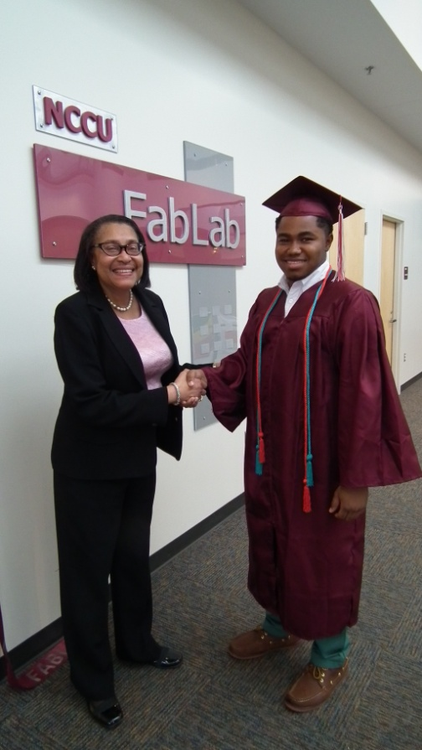

The North Carolina GlaxoSmithKline Foundation is supporting the STEM program at North Carolina Central University with a $1.5 million grant to increase the number of graduates with degrees in STEM disciplines.

